Opioids Social-Economic Impacts on Family Life
Student Name
Tutors Name
Institution Affiliation
Date

Opioids Social-Economic Impacts on Family Life
Abstract
It has revealed that more than a hundred individuals in western countries lost their lives due to continuous opioids misuse. Rampant overdose of opioids like heroin, fentanyl as well doctors prescribed pain relievers fosters a significant threat in the government and family functionality. According to the Betty Ford Institute For advocate recovery, doctors should be held responsible for the increasing misuse of opioids drugs, since they do not ask about the medical history of their patients, leading to the continuous prescription of opioids medication to their patients. The research evaluates question to be whether or not opioid misuse can have any contribution to social and economic life in a family, giving a research methodology as well as outlining the result from the study evidence.
Introduction
Opioids are prescribed pain relievers drugs which include hydrocodone, methadone, oxycodone, morphine, and buprenorphine; however illegal drugs such as heroin can also be included in the opioids group. Opioids have been reported as the most abused drug in the United States, since patients, as well as non-patients, overdose them. It was also noted that almost all of opioids drugs misused by individuals are doctor prescribed drugs. Doctors have been blamed on fueling the misuse of opioids drugs since they do not take caution when administering opioids drugs to their patients. Patients claim that doctors have not been concerned with knowing their health treatment history; instead, they prescribe them more opioids foster high misuse of opioids drugs. Scientists have come up with a lot of research about the impacts of opioids drug on both social and economical family life.
Research Methodology
The study will bring up the estimated social and economic effects of opioid overdose from 2013 to 2019 based on research evidence. In the study, the estimated cost of an opioid overdose will be calculated based on the effects it fosters to individuals life as well as its extension to the family at large. The health cost, which implies the treatment cost, lost productivity cost, as well as criminal cost related to opioid overdose, have increased by 3.5% from previous years. In this case data from the recent years have been used in the cost calculation. All the Cases of death rate were obtained from the databases of CDC WONDER where all deaths reported in the United States are recorded for future reference. The National survey on health and Drug Use ( 2015) documented that 37.8% of united state adult is under prescribed opioids; however, 12.5% of the adult overdose opioids. Also, the research conducted revealed that most adults who misuse opioids were jobless, had low income and above all, they had other health-related problems. The NSDUH (2014) research showed that 40.8% of individuals misusing opioids got prescriptions from allies. Modern scholarly research and experiments are used to account for the social and economic impacts of opioids misuse on family operations.
The Social- Economic Impacts of Opioids Overdose
Family breaks up cases have been reported to hike every year in the United States among the families with opioids overdose history. The quantitative research contacted by Do et al., (2018) associated opioid misuse with a high level of misconduct among the parents addicted to it. Upon opioid abuse, men have been reported to be violent to their spouse, since opioids heroine foster a false sense of anxiety among them. Severe cases of bodily injuries for both women and children have been reported from the quantitative research contacted revealing opioids victims as the leading cause of violent acts. Incidents of violence have persisted in the family causes the affected family groups to run away from home to look for save habitats. Family breakups are significant reasons why many children end up in the street.
In addition to family breakups, the research conducted by Leece et al., (2015) through Canadian Drug Safety and Effectiveness Research Network, showed any escalated mortality rate among the opioids abusers. The researchers based their study on the misuse of methadone which is one of the prescribed drugs from the doctors. The experimental results showed a significant increase in deaths among the individuals misusing methadone as compared to the report of previous years. Increase in deaths in the families has weakened their economic income since in most cases adults are engulfed by the addiction scenario. In most of the families, the death of a parent implies low economic income since they are the breadwinners. Many deaths caused by opioids, therefore, are the main reasons behind weak financial statements in the affected families.
Financial consideration may be based on opioids addiction. The National Survey of Drug Use and Health (NSDUH) 2014 reported that two millions of Americans are under addition of prescribed drugs. The individual’s overly dependent on the opioids have cost them a lot of money. Since addicted individuals cannot survive without opioids, they tend to be weaker as years pass by tempering completely with their role in the family provisions. Lack of money to purchase opioids among the addicted has triggered more criminal activities such as pickpocketing and bank robbery. Recently the NSDUH also revealed that there is a great number of opioids’ addicted individuals serving jail term while others are heavily penalized by the court of law when found guilty of committing criminal acts. Families lose a lot of money in the attempt to rescue their family members through sorting out the court penalties resulting in weak family financial statements.
The misuse of the opioids has affected productivity due to lack of sufficient workforce. Individuals addicted to opioids cannot execute duties related to employment. Extended time misuse of opioid weakens the recipient’s body and also affects their minds. The human brain is considered to be the most vital part of the organization since it controls all activities of the body; thus, tempering with its functionality has yielded low perception in terms of job execution. Low productivity results in short financial statement among the addicted individuals and this directly affects their family income.
Result
The results obtained from the NSDUH research using the stipulated methodologies revealed a significant increase in opioids patient's deaths as compared to previous year deaths. Those using both alcohol and other opioids like heroin are at high risk of death. Among the two million individuals who met DSM-IV norm due to their addiction, sixteen thousands of them died from opioid misuse. The rapid increase in the mortality rate has been illustrated in the graph below. The figure compares the deaths associated with overdose of opioids with time variation.
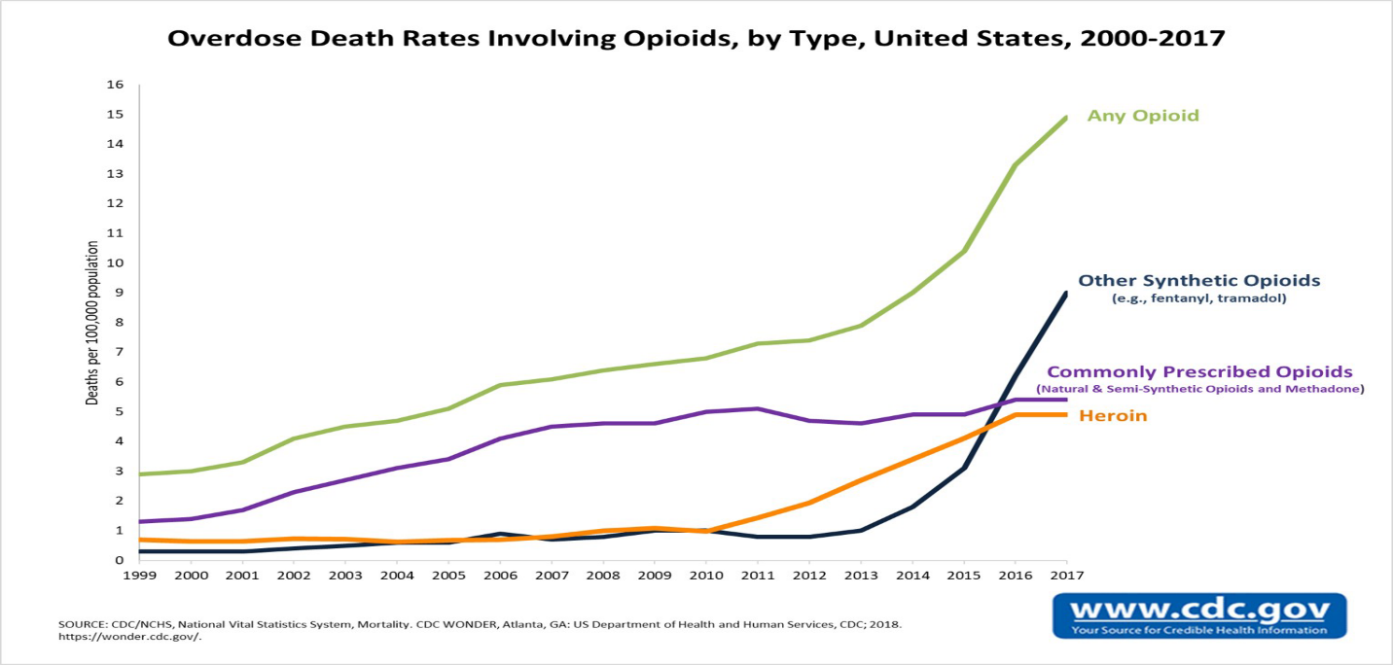
The research conducted through experimental information gathering (Florence et al., 2016) on the economic burden caused by opioids misuse was summarized in the pie chart below.

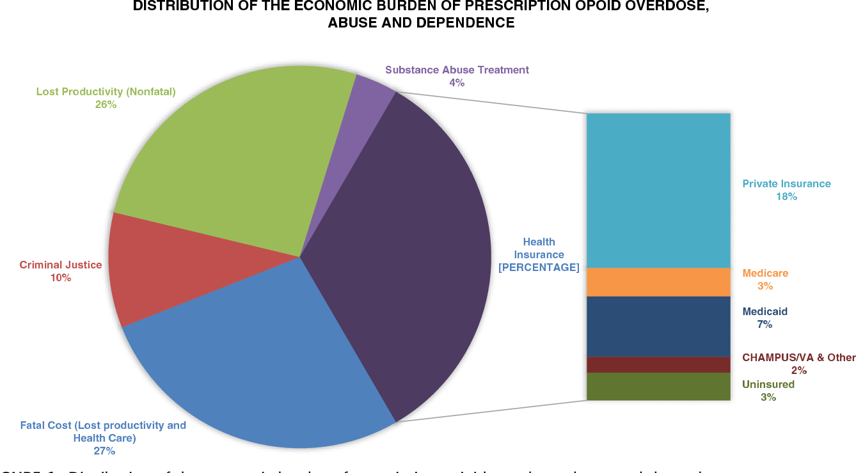
Another result brought up by federal state census bureau American community survey showed a considerable margin in increasing divorce rate due to opioids misuse. The divorce margin provided USCBACS corresponded the divorce margin obtained from databases of CDC WONDER. Divorce margin increased with time variation (years).

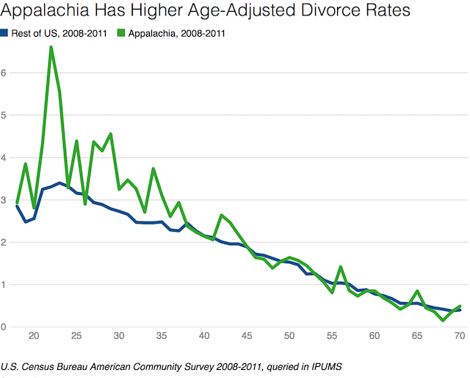
Discussion
The research conducted by NSDUH gave a variation of deaths related to opioids overdose with time. The experimental result revealed a rampant increase in the misuse of opioids in the United States predicting that in the coming year almost a quarter of American citizens will be addicted by opioids increase. The correlation in the graph suggests that the government should intervene to save its citizens from the predicted dilemma. There was no evidence in the decrease of deaths in the figure in comparison with time change suggesting that no institution or government organization has ever tried to control the death trend.
The result on the distribution of economic burden fueled by opioids overdose elaborated low-income family financial statement which triggered a lot of distress among the families. The loss of productivity covered 26% of the pie chat suggesting more poverty among the opioids addicted individuals in the future. Florence et al., (2016) through research confirmed opioids overdose had impacted negatively on the individual state of mind; thus they cannot profitably utilize their productive time. On another factor, the information from the CDC WONDER database (2011) has revealed simultaneous increase cases of a marriage break up. The research clearly showed that the breakup factors are fueled by misconducts among the opioids addicts in such a way that they become violent causing physical and emotional injuries to their loved ones. The violently affected spouse then move away to look for security and new habitats leading to family breakups.
Conclusion
A lot of research has been drawn from scholarly journals based on the research question which inquires if or not opioids overdose can have social-economic impacts on a family. Through the analysis, many social-economic effects about opioids misuse have been discussed and conclusion made based on the research results. It was found that opioids misuse can lead to Family breakups, a poor financial statement as well as death among the target individuals. The research paper findings have confidently answered the research question making it achieve its objections in a comprehensive manner.

References
Do Minh, T., Chang Vicky, C., Tibebu Semra, T. W., & Ugnat, A. M. (2018). Original quantitative research-Sentinel surveillance of suspected opioid-related poisonings and injuries: trends and context derived from the electronic Canadian Hospitals Injury Reporting and Prevention Program, March 2011 to June 2017. Health Promotion and Chronic Disease Prevention in Canada: Research, Policy and Practice, 38(9), 317.
Florence, C., Luo, F., Xu, L., & Zhou, C. (2016). The economic burden of prescription opioid overdose, abuse, and dependence in the United States, 2013. Medical care, 54(10), 901.
Leece, P., Cavacuiti, C., Macdonald, E. M., Gomes, T., Kahan, M., Srivastava, A., ... & Canadian Drug Safety and Effectiveness Research Network. (2015). Predictors of opioid-related death during methadone therapy. Journal of substance abuse treatment, 57, 30-35.
Miech, R., Johnston, L., O’Malley, P. M., Keyes, K. M., & Heard, K. (2015). Prescription opioids in adolescence and future opioid misuse. Pediatrics, 136(5), e1169.

